OBJECTIVE
The objective of this project is to analyse e-commerce transaction data to:
- Understand sales performance.
- Identify top-performing products and categories.
- Analyse customer behaviour.
- Evaluate store and regional performance.
- Generate data-driven business insights.
DATASET DESCRIPTION
The dataset contains transactional data including:
- Customer details (Age, Gender, Location)
- Product information (Category, Brand, Price)
- Store details (Region, Type)
- Sales metrics (Quantity, Discount, Total Amount)
TOOLS USED
Microsoft Excel
- Pivot Tables
- Charts
- Formulas
- Conditional Formatting
- Power Query
DATA CLEANING
- Removed duplicates.
- Checked missing values.
- Standardized text (Gender, Category).
- Ensured numeric columns (Price, Quantity).
EXPLORATORY DATA ANALYSIS (EDA)
Sales Performance
- Total Revenue calculated
- Identified high-value transactions
Category Analysis
- Clothing → High sales volume by total revenue
- Home → Consistent performance
Customer Analysis
- Silver→ Highest contributors by unit price in top Cities.
- Bronze → Lowest spending segment.
Payment Analysis
- Credit Card & PayPal dominate.
- COD is less preferred.
Discount Impact
- Higher discounts → Increased quantity purchased.
- Helps boost sales volume.
EXCEL DASHBOARD DESIGN
KPIs
- Total Revenue
- Total Orders
- Average Unit Price
- Gender
- Total Customers

Visualizations

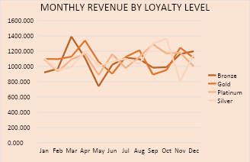
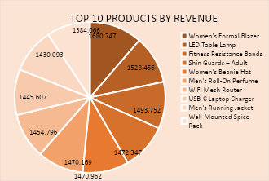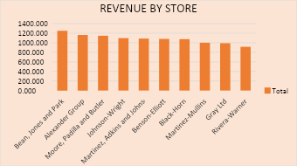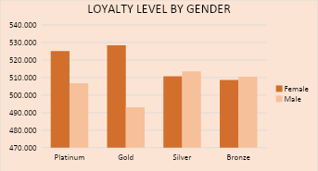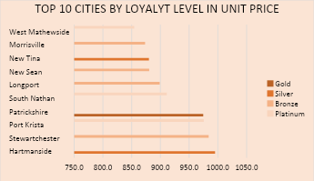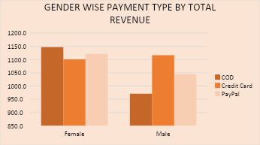
INSIGHTS AND RECOMMENDATION
Revenue & Seasonality Insights
- Revenue peaks in March–April, indicating strong seasonal demand.
- Sharp drop in May across all loyalty segments → possible off-season or weak campaigns.
- Silver customers show a huge spike in October, suggesting event-driven sales.
Action:
Plan marketing campaigns before peak months and fix May slump with discounts or promotions.
Loyalty Program Insights
- Gold customers generate the highest revenue, making them the most valuable segment.
- Platinum customers are consistent but slightly below GOLD overall.
Action:
Strengthen Gold loyalty benefits and Convert Silver customers → Gold through incentives
Product Performance Insights
- Fashion products dominate (Blazer, Jacket, Beanie).
- Electronics and fitness items also perform strongly.
Action:
Create product bundles (fashion + accessories/electronics).
Store Performance Insights
- Large variation between stores (top vs bottom).
- Some stores underperform significantly.
Action:
Analyse top store strategies (inventory, location, pricing) and improve or audit low-performing stores.
Customer Behaviour Insights
- Female customers spend ~7–8% more than males
- Female Platinum segment is highest value
Action:
Target women with premium product campaigns and use personalized offers & recommendations.
Payment Behaviour Insights
- Credit cards are the most preferred overall.
- Females prefer COD, males prefer credit cards.
Action:
Offer COD incentives for female users and Provide card discounts/cashbacks for males.
FUTURE SCOPE
- Predictive analysis (Sales Forecasting).
- Customer segmentation using clustering.
- Integration with Power BI for advanced dashboards.
CONCLUSION
This project demonstrates how Excel can be used effectively to Analyse large datasets, generate actionable insights and Support business decision-making. It highlights the importance of data-driven strategies in e-commerce growth.

